Transaction
- The transaction is a set of logically related operation. It contains a group of tasks.
- A transaction is an action or series of actions. It is performed by a single user to perform operations for accessing the contents of the database.
Example: Suppose an employee of bank transfers Rs 800 from X's account to Y's account. This small transaction contains several low-level tasks:
X's Account
- Open_Account(X)
- Old_Balance = X.balance
- New_Balance = Old_Balance - 800
- X.balance = New_Balance
- Close_Account(X)
Y's Account
- Open_Account(Y)
- Old_Balance = Y.balance
- New_Balance = Old_Balance + 800
- Y.balance = New_Balance
- Close_Account(Y)

Operations of Transaction:
Following are the main operations of transaction:
Read(X): Read operation is used to read the value of X from the database and stores it in a buffer in main memory.
Write(X): Write operation is used to write the value back to the database from the buffer.
Let's take an example to debit transaction from an account which consists of following operations:
- 1. R(X);
- 2. X = X - 500;
- 3. W(X);
Let's assume the value of X before starting of the transaction is 4000.
- The first operation reads X's value from database and stores it in a buffer.
- The second operation will decrease the value of X by 500. So buffer will contain 3500.
- The third operation will write the buffer's value to the database. So X's final value will be 3500.
But it may be possible that because of the failure of hardware, software or power, etc. that transaction may fail before finished all the operations in the set.
For example: If in the above transaction, the debit transaction fails after executing operation 2 then X's value will remain 4000 in the database which is not acceptable by the bank.
To solve this problem, we have two important operations:
Commit: It is used to save the work done permanently.
Rollback: It is used to undo the work done.

Transaction property
The transaction has the four properties. These are used to maintain consistency in a database, before and after the transaction.

Property of Transaction
- Atomicity
- Consistency
- Isolation
- Durability
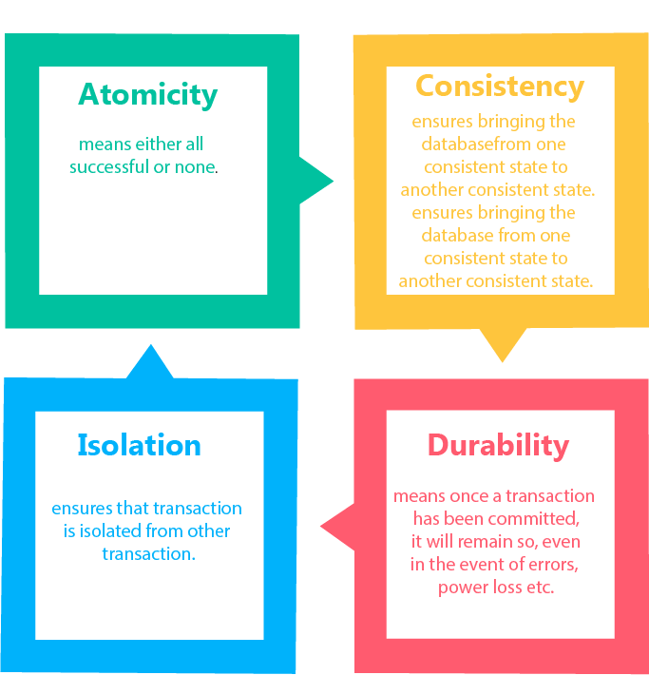

Atomicity
- It states that all operations of the transaction take place at once if not, the transaction is aborted.
- There is no midway, i.e., the transaction cannot occur partially. Each transaction is treated as one unit and either run to completion or is not executed at all.
Atomicity involves the following two operations:
Abort: If a transaction aborts then all the changes made are not visible.
Commit: If a transaction commits then all the changes made are visible.
Example: Let's assume that following transaction T consisting of T1 and T2. A consists of Rs 600 and B consists of Rs 300. Transfer Rs 100 from account A to account B.
T1 | T2
Read(A)  A:= A-100  Write(A) | Read(B)  Y:= Y+100  Write(B)
After completion of the transaction, A consists of Rs 500 and B consists of Rs 400.
If the transaction T fails after the completion of transaction T1 but before completion of transaction T2, then the amount will be deducted from A but not added to B. This shows the inconsistent database state. In order to ensure correctness of database state, the transaction must be executed in entirety.

Consistency
- The integrity constraints are maintained so that the database is consistent before and after the transaction.
- The execution of a transaction will leave a database in either its prior stable state or a new stable state.
- The consistent property of database states that every transaction sees a consistent database instance.
- The transaction is used to transform the database from one consistent state to another consistent state.
For example: The total amount must be maintained before or after the transaction.
- Total before T occurs = 600+300=900
- Total after T occurs= 500+400=900
Therefore, the database is consistent. In the case when T1 is completed but T2 fails, then inconsistency will occur.

Isolation
- It shows that the data which is used at the time of execution of a transaction cannot be used by the second transaction until the first one is completed.
- In isolation, if the transaction T1 is being executed and using the data item X, then that data item can't be accessed by any other transaction T2 until the transaction T1 ends.
- The concurrency control subsystem of the DBMS enforced the isolation property.

Durability
- The durability property is used to indicate the performance of the database's consistent state. It states that the transaction made the permanent changes.
- They cannot be lost by the erroneous operation of a faulty transaction or by the system failure. When a transaction is completed, then the database reaches a state known as the consistent state. That consistent state cannot be lost, even in the event of a system's failure.
- The recovery subsystem of the DBMS has the responsibility of Durability property.

States of Transaction
In a database, the transaction can be in one of the following states -
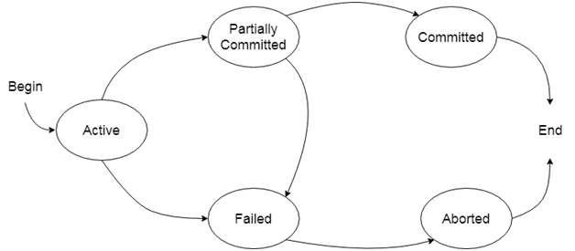

Active state
- The active state is the first state of every transaction. In this state, the transaction is being executed.
- For example: Insertion or deletion or updating a record is done here. But all the records are still not saved to the database.

Partially committed
- In the partially committed state, a transaction executes its final operation, but the data is still not saved to the database.
- In the total mark calculation example, a final display of the total marks step is executed in this state.

Committed
A transaction is said to be in a committed state if it executes all its operations successfully. In this state, all the effects are now permanently saved on the database system.

Failed state
- If any of the checks made by the database recovery system fails, then the transaction is said to be in the failed state.
- In the example of total mark calculation, if the database is not able to fire a query to fetch the marks, then the transaction will fail to execute.

Aborted
- If any of the checks fail and the transaction has reached a failed state then the database recovery system will make sure that the database is in its previous consistent state. If not then it will abort or roll back the transaction to bring the database into a consistent state.
- If the transaction fails in the middle of the transaction then before executing the transaction, all the executed transactions are rolled back to its consistent state.
- After aborting the transaction, the database recovery module will select one of the two operations:
  - Re-start the transaction
  - Kill the transaction

Schedule
A series of operation from one transaction to another transaction is known as schedule. It is used to preserve the order of the operation in each of the individual transaction.
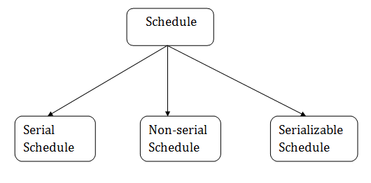

1. Serial Schedule
The serial schedule is a type of schedule where one transaction is executed completely before starting another transaction. In the serial schedule, when the first transaction completes its cycle, then the next transaction is executed.
For example: Suppose there are two transactions T1 and T2 which have some operations. If it has no interleaving of operations, then there are the following two possible outcomes:
- Execute all the operations of T1 which was followed by all the operations of T2.
- Execute all the operations of T1 which was followed by all the operations of T2.
- In the given (a) figure, Schedule A shows the serial schedule where T1 followed by T2.
- In the given (b) figure, Schedule B shows the serial schedule where T2 followed by T1.

2. Non-serial Schedule
- If interleaving of operations is allowed, then there will be non-serial schedule.
- It contains many possible orders in which the system can execute the individual operations of the transactions.
- In the given figure (c) and (d), Schedule C and Schedule D are the non-serial schedules. It has interleaving of operations.

3. Serializable schedule
- The serializability of schedules is used to find non-serial schedules that allow the transaction to execute concurrently without interfering with one another.
- It identifies which schedules are correct when executions of the transaction have interleaving of their operations.
- A non-serial schedule will be serializable if its result is equal to the result of its transactions executed serially.
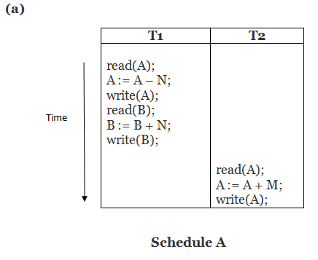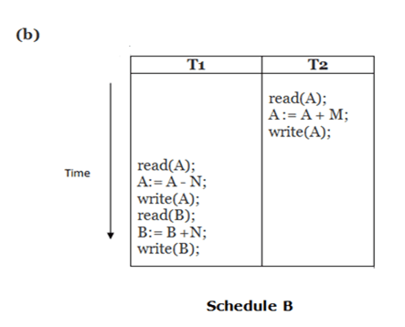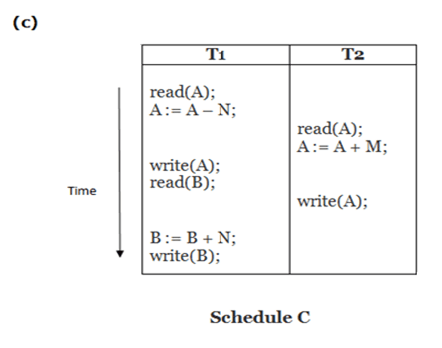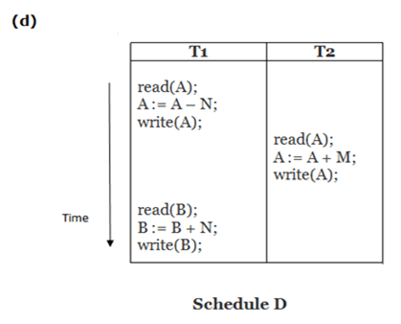
Here,
Schedule A and Schedule B are serial schedule.
Schedule C and Schedule D are Non-serial schedule.

Testing of Serializability
Serialization Graph is used to test the Serializability of a schedule.
Assume a schedule S. For S, we construct a graph known as precedence graph. This graph has a pair G = (V, E), where V consists a set of vertices, and E consists a set of edges. The set of vertices is used to contain all the transactions participating in the schedule. The set of edges is used to contain all edges Ti ->Tj for which one of the three conditions holds:
- Create a node Ti → Tj if Ti executes write (Q) before Tj executes read (Q).
- Create a node Ti → Tj if Ti executes read (Q) before Tj executes write (Q).
- Create a node Ti → Tj if Ti executes write (Q) before Tj executes write (Q).
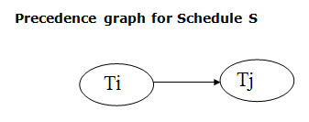
- If a precedence graph contains a single edge Ti → Tj, then all the instructions of Ti are executed before the first instruction of Tj is executed.
- If a precedence graph for schedule S contains a cycle, then S is non-serializable. If the precedence graph has no cycle, then S is known as serializable.
For example:
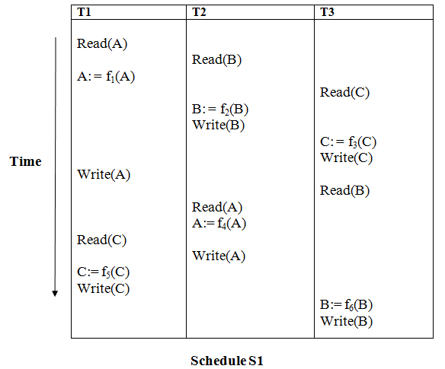
Explanation:
00:00/06:36
Read(A): In T1, no subsequent writes to A, so no new edges
Read(B): In T2, no subsequent writes to B, so no new edges
Read(C): In T3, no subsequent writes to C, so no new edges
Write(B): B is subsequently read by T3, so add edge T2 → T3
Write(C): C is subsequently read by T1, so add edge T3 → T1
Write(A): A is subsequently read by T2, so add edge T1 → T2
Write(A): In T2, no subsequent reads to A, so no new edges
Write(C): In T1, no subsequent reads to C, so no new edges
Write(B): In T3, no subsequent reads to B, so no new edges

Precedence graph for schedule S1:
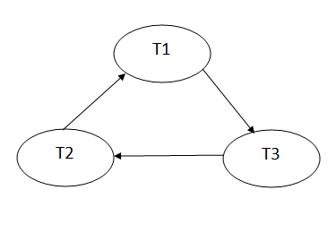
The precedence graph for schedule S1 contains a cycle that's why Schedule S1 is non-serializable.
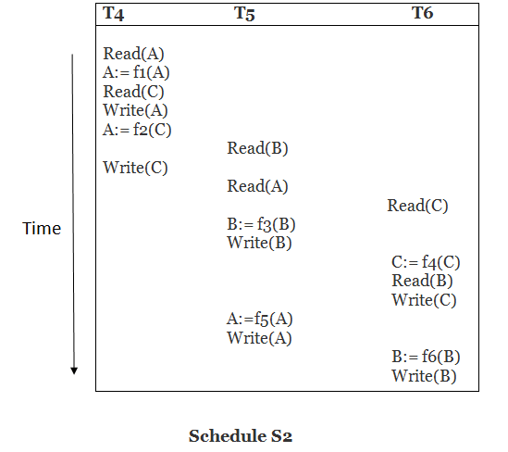
Explanation:
Read(A): In T4,no subsequent writes to A, so no new edges
Read(C): In T4, no subsequent writes to C, so no new edges
Write(A): A is subsequently read by T5, so add edge T4 → T5
Read(B): In T5,no subsequent writes to B, so no new edges
Write(C): C is subsequently read by T6, so add edge T4 → T6
Write(B): A is subsequently read by T6, so add edge T5 → T6
Write(C): In T6, no subsequent reads to C, so no new edges
Write(A): In T5, no subsequent reads to A, so no new edges
Write(B): In T6, no subsequent reads to B, so no new edges

Precedence graph for schedule S2:
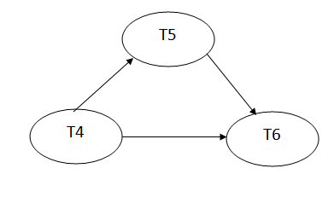
The precedence graph for schedule S2 contains no cycle that's why ScheduleS2 is serializable.

Conflict Serializable Schedule
- A schedule is called conflict serializability if after swapping of non-conflicting operations, it can transform into a serial schedule.
- The schedule will be a conflict serializable if it is conflict equivalent to a serial schedule.

Conflicting Operations
The two operations become conflicting if all conditions satisfy:
- Both belong to separate transactions.
- They have the same data item.
- They contain at least one write operation.

Example:
Swapping is possible only if S1 and S2 are logically equal.
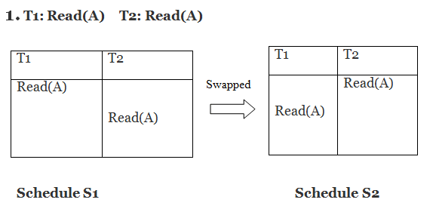
Here, S1 = S2. That means it is non-conflict.
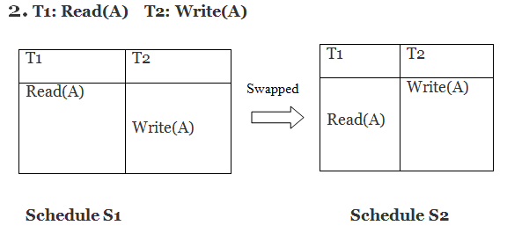
Here, S1 ≠ S2. That means it is conflict.

Conflict Equivalent
In the conflict equivalent, one can be transformed to another by swapping non-conflicting operations. In the given example, S2 is conflict equivalent to S1 (S1 can be converted to S2 by swapping non-conflicting operations).
Two schedules are said to be conflict equivalent if and only if:
- They contain the same set of the transaction.
- If each pair of conflict operations are ordered in the same way.

Example:
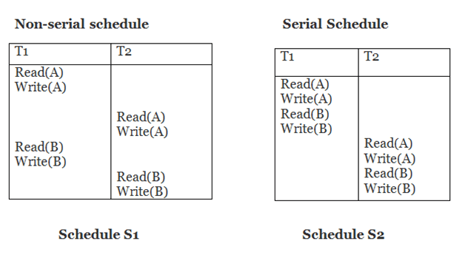
Schedule S2 is a serial schedule because, in this, all operations of T1 are performed before starting any operation of T2. Schedule S1 can be transformed into a serial schedule by swapping non-conflicting operations of S1.
After swapping of non-conflict operations, the schedule S1 becomes:
T1 | T2
Read(A)  Write(A)  Read(B)  Write(B) | Read(A)  Write(A)  Read(B)  Write(B)
Since, S1 is conflict serializable.

View Serializability
- A schedule will view serializable if it is view equivalent to a serial schedule.
- If a schedule is conflict serializable, then it will be view serializable.
- The view serializable which does not conflict serializable contains blind writes.

View Equivalent
Two schedules S1 and S2 are said to be view equivalent if they satisfy the following conditions:

1. Initial Read
An initial read of both schedules must be the same. Suppose two schedule S1 and S2. In schedule S1, if a transaction T1 is reading the data item A, then in S2, transaction T1 should also read A.
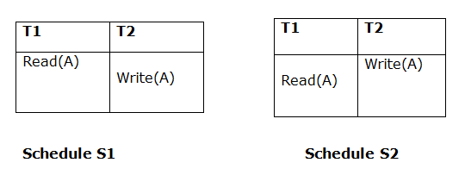
Above two schedules are view equivalent because Initial read operation in S1 is done by T1 and in S2 it is also done by T1.

2. Updated Read
In schedule S1, if Ti is reading A which is updated by Tj then in S2 also, Ti should read A which is updated by Tj.
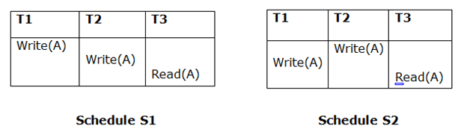
Above two schedules are not view equal because, in S1, T3 is reading A updated by T2 and in S2, T3 is reading A updated by T1.

3. Final Write
A final write must be the same between both the schedules. In schedule S1, if a transaction T1 updates A at last then in S2, final writes operations should also be done by T1.
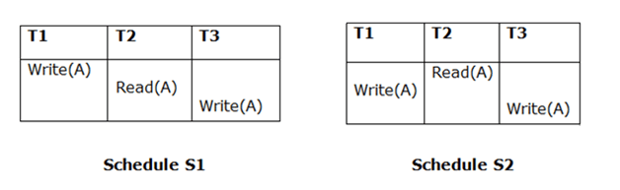
Above two schedules is view equal because Final write operation in S1 is done by T3 and in S2, the final write operation is also done by T3.
Example:
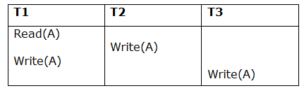
Schedule S
With 3 transactions, the total number of possible schedule
- = 3! = 6
- S1 = <T1 T2 T3>
- S2 = <T1 T3 T2>
- S3 = <T2 T3 T1>
- S4 = <T2 T1 T3>
- S5 = <T3 T1 T2>
- S6 = <T3 T2 T1>
Taking first schedule S1:
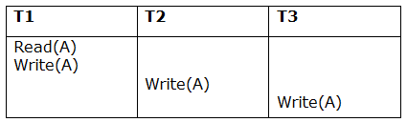
Schedule S1
Step 1: final updation on data items
In both schedules S and S1, there is no read except the initial read that's why we don't need to check that condition.
Step 2: Initial Read
The initial read operation in S is done by T1 and in S1, it is also done by T1.
Step 3: Final Write
The final write operation in S is done by T3 and in S1, it is also done by T3. So, S and S1 are view Equivalent.
The first schedule S1 satisfies all three conditions, so we don't need to check another schedule.
Hence, view equivalent serial schedule is:
- T1 → T2 → T3

Recoverability of Schedule
Sometimes a transaction may not execute completely due to a software issue, system crash or hardware failure. In that case, the failed transaction has to be rollback. But some other transaction may also have used value produced by the failed transaction. So we also have to rollback those transactions.
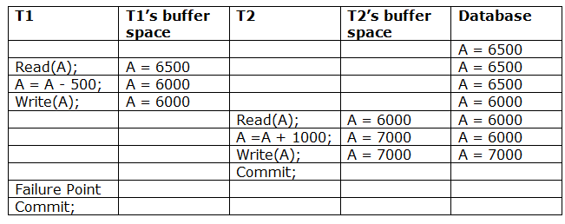
The above table 1 shows a schedule which has two transactions. T1 reads and writes the value of A and that value is read and written by T2. T2 commits but later on, T1 fails. Due to the failure, we have to rollback T1. T2 should also be rollback because it reads the value written by T1, but T2 can't be rollback because it already committed. So this type of schedule is known as irrecoverable schedule.
Irrecoverable schedule: The schedule will be irrecoverable if Tj reads the updated value of Ti and Tj committed before Ti commit.
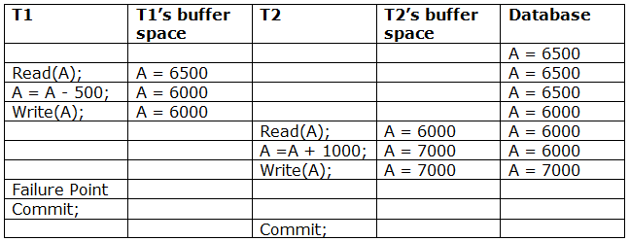
The above table 2 shows a schedule with two transactions. Transaction T1 reads and writes A, and that value is read and written by transaction T2. But later on, T1 fails. Due to this, we have to rollback T1. T2 should be rollback because T2 has read the value written by T1. As it has not committed before T1 commits so we can rollback transaction T2 as well. So it is recoverable with cascade rollback.
00:00/01:27
4.3M
74
Twitter Announces Long-Awaited Plan for Adding an Edit Feature
Recoverable with cascading rollback: The schedule will be recoverable with cascading rollback if Tj reads the updated value of Ti. Commit of Tj is delayed till commit of Ti.
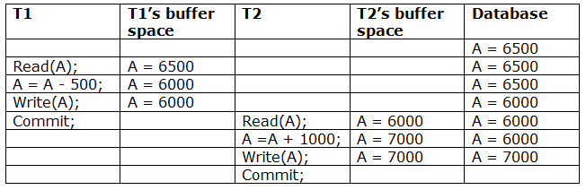
The above Table 3 shows a schedule with two transactions. Transaction T1 reads and write A and commits, and that value is read and written by T2. So this is a cascade less recoverable schedule.

Failure Classification
To find that where the problem has occurred, we generalize a failure into the following categories:
- Transaction failure
- System crash
- Disk failure

1. Transaction failure
The transaction failure occurs when it fails to execute or when it reaches a point from where it can't go any further. If a few transaction or process is hurt, then this is called as transaction failure.
Reasons for a transaction failure could be -
  - Logical errors: If a transaction cannot complete due to some code error or an internal error condition, then the logical error occurs.
  - Syntax error: It occurs where the DBMS itself terminates an active transaction because the database system is not able to execute it. For example, The system aborts an active transaction, in case of deadlock or resource unavailability.

2. System Crash
  - System failure can occur due to power failure or other hardware or software failure. Example: Operating system error.
Fail-stop assumption: In the system crash, non-volatile storage is assumed not to be corrupted.

3. Disk Failure
  - It occurs where hard-disk drives or storage drives used to fail frequently. It was a common problem in the early days of technology evolution.
  - Disk failure occurs due to the formation of bad sectors, disk head crash, and unreachability to the disk or any other failure, which destroy all or part of disk storage.

Log-Based Recovery
- The log is a sequence of records. Log of each transaction is maintained in some stable storage so that if any failure occurs, then it can be recovered from there.
- If any operation is performed on the database, then it will be recorded in the log.
- But the process of storing the logs should be done before the actual transaction is applied in the database.
Let's assume there is a transaction to modify the City of a student. The following logs are written for this transaction.
- When the transaction is initiated, then it writes 'start' log.
  - <Tn, Start>
- When the transaction modifies the City from 'Noida' to 'Bangalore', then another log is written to the file.
  - <Tn, City, 'Noida', 'Bangalore' >
- When the transaction is finished, then it writes another log to indicate the end of the transaction.
  - <Tn, Commit>
There are two approaches to modify the database:

1. Deferred database modification:
- The deferred modification technique occurs if the transaction does not modify the database until it has committed.
- In this method, all the logs are created and stored in the stable storage, and the database is updated when a transaction commits.

2. Immediate database modification:
- The Immediate modification technique occurs if database modification occurs while the transaction is still active.
- In this technique, the database is modified immediately after every operation. It follows an actual database modification.

Recovery using Log records
When the system is crashed, then the system consults the log to find which transactions need to be undone and which need to be redone.
- If the log contains the record <Ti, Start> and <Ti, Commit> or <Ti, Commit>, then the Transaction Ti needs to be redone.
- If log contains record<T_{n}, Start> but does not contain the record either <Ti, commit> or <Ti, abort>, then the Transaction Ti needs to be undone.

Checkpoint
- The checkpoint is a type of mechanism where all the previous logs are removed from the system and permanently stored in the storage disk.
- The checkpoint is like a bookmark. While the execution of the transaction, such checkpoints are marked, and the transaction is executed then using the steps of the transaction, the log files will be created.
- When it reaches to the checkpoint, then the transaction will be updated into the database, and till that point, the entire log file will be removed from the file. Then the log file is updated with the new step of transaction till next checkpoint and so on.
- The checkpoint is used to declare a point before which the DBMS was in the consistent state, and all transactions were committed.

Recovery using Checkpoint
In the following manner, a recovery system recovers the database from this failure:
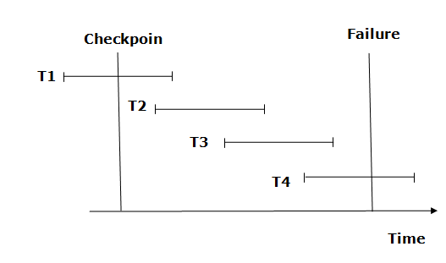
- The recovery system reads log files from the end to start. It reads log files from T4 to T1.
- Recovery system maintains two lists, a redo-list, and an undo-list.
- The transaction is put into redo state if the recovery system sees a log with <Tn, Start> and <Tn, Commit> or just <Tn, Commit>. In the redo-list and their previous list, all the transactions are removed and then redone before saving their logs.
- For example: In the log file, transaction T2 and T3 will have <Tn, Start> and <Tn, Commit>. The T1 transaction will have only <Tn, commit> in the log file. That's why the transaction is committed after the checkpoint is crossed. Hence it puts T1, T2 and T3 transaction into redo list.
- The transaction is put into undo state if the recovery system sees a log with <Tn, Start> but no commit or abort log found. In the undo-list, all the transactions are undone, and their logs are removed.
- For example: Transaction T4 will have <Tn, Start>. So T4 will be put into undo list since this transaction is not yet complete and failed amid.

Deadlock in DBMS
A deadlock is a condition where two or more transactions are waiting indefinitely for one another to give up locks. Deadlock is said to be one of the most feared complications in DBMS as no task ever gets finished and is in waiting state forever.
For example: In the student table, transaction T1 holds a lock on some rows and needs to update some rows in the grade table. Simultaneously, transaction T2 holds locks on some rows in the grade table and needs to update the rows in the Student table held by Transaction T1.
Now, the main problem arises. Now Transaction T1 is waiting for T2 to release its lock and similarly, transaction T2 is waiting for T1 to release its lock. All activities come to a halt state and remain at a standstill. It will remain in a standstill until the DBMS detects the deadlock and aborts one of the transactions.
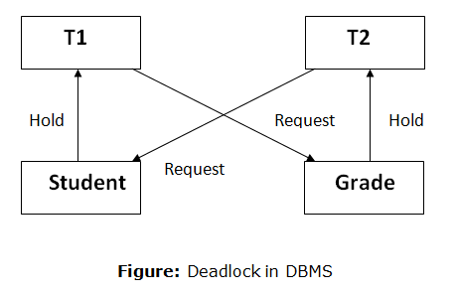

Deadlock Avoidance
- When a database is stuck in a deadlock state, then it is better to avoid the database rather than aborting or restating the database. This is a waste of time and resource.
- Deadlock avoidance mechanism is used to detect any deadlock situation in advance. A method like "wait for graph" is used for detecting the deadlock situation but this method is suitable only for the smaller database. For the larger database, deadlock prevention method can be used.

Deadlock Detection
In a database, when a transaction waits indefinitely to obtain a lock, then the DBMS should detect whether the transaction is involved in a deadlock or not. The lock manager maintains a Wait for the graph to detect the deadlock cycle in the database.

Wait for Graph
- This is the suitable method for deadlock detection. In this method, a graph is created based on the transaction and their lock. If the created graph has a cycle or closed loop, then there is a deadlock.
- The wait for the graph is maintained by the system for every transaction which is waiting for some data held by the others. The system keeps checking the graph if there is any cycle in the graph.
The wait for a graph for the above scenario is shown below:
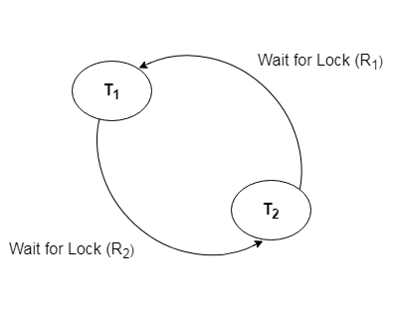

Deadlock Prevention
- Deadlock prevention method is suitable for a large database. If the resources are allocated in such a way that deadlock never occurs, then the deadlock can be prevented.
- The Database management system analyzes the operations of the transaction whether they can create a deadlock situation or not. If they do, then the DBMS never allowed that transaction to be executed.

Wait-Die scheme
In this scheme, if a transaction requests for a resource which is already held with a conflicting lock by another transaction then the DBMS simply checks the timestamp of both transactions. It allows the older transaction to wait until the resource is available for execution.
Let's assume there are two transactions Ti and Tj and let TS(T) is a timestamp of any transaction T. If T2 holds a lock by some other transaction and T1 is requesting for resources held by T2 then the following actions are performed by DBMS:
- Check if TS(Ti) < TS(Tj) - If Ti is the older transaction and Tj has held some resource, then Ti is allowed to wait until the data-item is available for execution. That means if the older transaction is waiting for a resource which is locked by the younger transaction, then the older transaction is allowed to wait for resource until it is available.
- Check if TS(T_{i}) < TS(Tj) - If Ti is older transaction and has held some resource and if Tj is waiting for it, then Tj is killed and restarted later with the random delay but with the same timestamp.

Wound wait scheme
- In wound wait scheme, if the older transaction requests for a resource which is held by the younger transaction, then older transaction forces younger one to kill the transaction and release the resource. After the minute delay, the younger transaction is restarted but with the same timestamp.
- If the older transaction has held a resource which is requested by the Younger transaction, then the younger transaction is asked to wait until older releases it.

DBMS Concurrency Control
Concurrency Control is the management procedure that is required for controlling concurrent execution of the operations that take place on a database.
But before knowing about concurrency control, we should know about concurrent execution.

Concurrent Execution in DBMS
- In a multi-user system, multiple users can access and use the same database at one time, which is known as the concurrent execution of the database. It means that the same database is executed simultaneously on a multi-user system by different users.
- While working on the database transactions, there occurs the requirement of using the database by multiple users for performing different operations, and in that case, concurrent execution of the database is performed.
- The thing is that the simultaneous execution that is performed should be done in an interleaved manner, and no operation should affect the other executing operations, thus maintaining the consistency of the database. Thus, on making the concurrent execution of the transaction operations, there occur several challenging problems that need to be solved.

Problems with Concurrent Execution
In a database transaction, the two main operations are READ and WRITE operations. So, there is a need to manage these two operations in the concurrent execution of the transactions as if these operations are not performed in an interleaved manner, and the data may become inconsistent. So, the following problems occur with the Concurrent Execution of the operations:

Problem 1: Lost Update Problems (W - W Conflict)
The problem occurs when two different database transactions perform the read/write operations on the same database items in an interleaved manner (i.e., concurrent execution) that makes the values of the items incorrect hence making the database inconsistent.
For example:
Consider the below diagram where two transactions T_{X} and T_{Y}, are performed on the same account A where the balance of account A is $300.
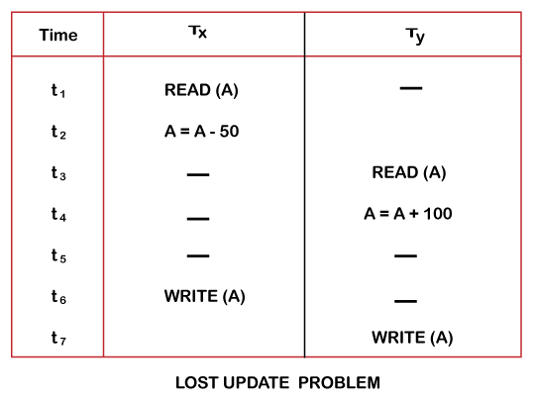
- At time t1, transaction T_{X} reads the value of account A, i.e., $300 (only read).
- At time t2, transaction T_{X} deducts $50 from account A that becomes $250 (only deducted and not updated/write).
- Alternately, at time t3, transaction T_{Y} reads the value of account A that will be $300 only because T_{X} didn't update the value yet.
- At time t4, transaction T_{Y} adds $100 to account A that becomes $400 (only added but not updated/write).
- At time t6, transaction T_{X} writes the value of account A that will be updated as $250 only, as T_{Y} didn't update the value yet.
- Similarly, at time t7, transaction T_{Y} writes the values of account A, so it will write as done at time t4 that will be $400. It means the value written by T_{X} is lost, i.e., $250 is lost.
Hence data becomes incorrect, and database sets to inconsistent.

Dirty Read Problems (W-R Conflict)
The dirty read problem occurs when one transaction updates an item of the database, and somehow the transaction fails, and before the data gets rollback, the updated database item is accessed by another transaction. There comes the Read-Write Conflict between both transactions.
For example:
Consider two transactions T_{X} and T_{Y} in the below diagram performing read/write operations on account A where the available balance in account A is $300:
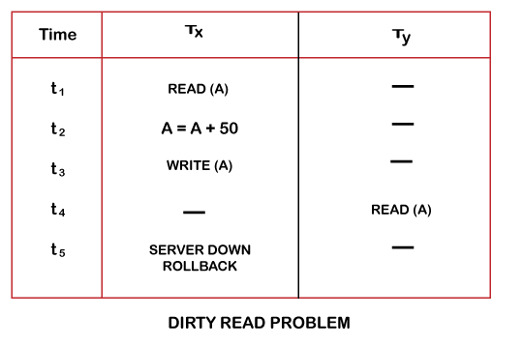
- At time t1, transaction T_{X} reads the value of account A, i.e., $300.
- At time t2, transaction T_{X} adds $50 to account A that becomes $350.
- At time t3, transaction T_{X} writes the updated value in account A, i.e., $350.
- Then at time t4, transaction T_{Y} reads account A that will be read as $350.
- Then at time t5, transaction T_{X} rollbacks due to server problem, and the value changes back to $300 (as initially).
- But the value for account A remains $350 for transaction T_{Y} as committed, which is the dirty read and therefore known as the Dirty Read Problem.

Unrepeatable Read Problem (W-R Conflict)
Also known as Inconsistent Retrievals Problem that occurs when in a transaction, two different values are read for the same database item.
For example:
Consider two transactions, T_{X} and T_{Y}, performing the read/write operations on account A, having an available balance = $300. The diagram is shown below:
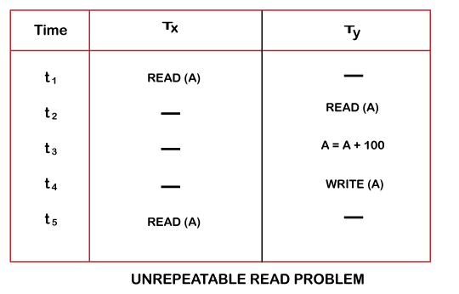
- At time t1, transaction T_{X} reads the value from account A, i.e., $300.
- At time t2, transaction T_{Y} reads the value from account A, i.e., $300.
- At time t3, transaction T_{Y} updates the value of account A by adding $100 to the available balance, and then it becomes $400.
- At time t4, transaction T_{Y} writes the updated value, i.e., $400.
- After that, at time t5, transaction T_{X} reads the available value of account A, and that will be read as $400.
- It means that within the same transaction T_{X}, it reads two different values of account A, i.e., $ 300 initially, and after updation made by transaction T_{Y}, it reads $400. It is an unrepeatable read and is therefore known as the Unrepeatable read problem.
Thus, in order to maintain consistency in the database and avoid such problems that take place in concurrent execution, management is needed, and that is where the concept of Concurrency Control comes into role.

Concurrency Control
Concurrency Control is the working concept that is required for controlling and managing the concurrent execution of database operations and thus avoiding the inconsistencies in the database. Thus, for maintaining the concurrency of the database, we have the concurrency control protocols.

Concurrency Control Protocols
The concurrency control protocols ensure the atomicity, consistency, isolation, durability and serializability of the concurrent execution of the database transactions. Therefore, these protocols are categorized as:
- Lock Based Concurrency Control Protocol
- Time Stamp Concurrency Control Protocol
- Validation Based Concurrency Control Protocol
We will understand and discuss each protocol one by one in our next sections.

Lock-Based Protocol
In this type of protocol, any transaction cannot read or write data until it acquires an appropriate lock on it. There are two types of lock:
1. Shared lock:
- It is also known as a Read-only lock. In a shared lock, the data item can only read by the transaction.
- It can be shared between the transactions because when the transaction holds a lock, then it can't update the data on the data item.
2. Exclusive lock:
- In the exclusive lock, the data item can be both reads as well as written by the transaction.
- This lock is exclusive, and in this lock, multiple transactions do not modify the same data simultaneously.

There are four types of lock protocols available:

1. Simplistic lock protocol
It is the simplest way of locking the data while transaction. Simplistic lock-based protocols allow all the transactions to get the lock on the data before insert or delete or update on it. It will unlock the data item after completing the transaction.

2. Pre-claiming Lock Protocol
- Pre-claiming Lock Protocols evaluate the transaction to list all the data items on which they need locks.
- Before initiating an execution of the transaction, it requests DBMS for all the lock on all those data items.
- If all the locks are granted then this protocol allows the transaction to begin. When the transaction is completed then it releases all the lock.
- If all the locks are not granted then this protocol allows the transaction to rolls back and waits until all the locks are granted.
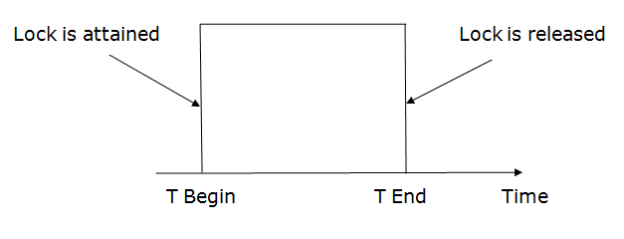

3. Two-phase locking (2PL)
- The two-phase locking protocol divides the execution phase of the transaction into three parts.
- In the first part, when the execution of the transaction starts, it seeks permission for the lock it requires.
- In the second part, the transaction acquires all the locks. The third phase is started as soon as the transaction releases its first lock.
- In the third phase, the transaction cannot demand any new locks. It only releases the acquired locks.
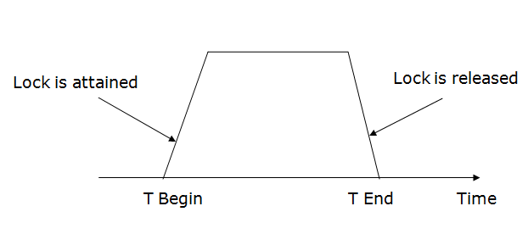
There are two phases of 2PL:
Growing phase: In the growing phase, a new lock on the data item may be acquired by the transaction, but none can be released.
Shrinking phase: In the shrinking phase, existing lock held by the transaction may be released, but no new locks can be acquired.
In the below example, if lock conversion is allowed then the following phase can happen:
- Upgrading of lock (from S(a) to X (a)) is allowed in growing phase.
- Downgrading of lock (from X(a) to S(a)) must be done in shrinking phase.
Example:
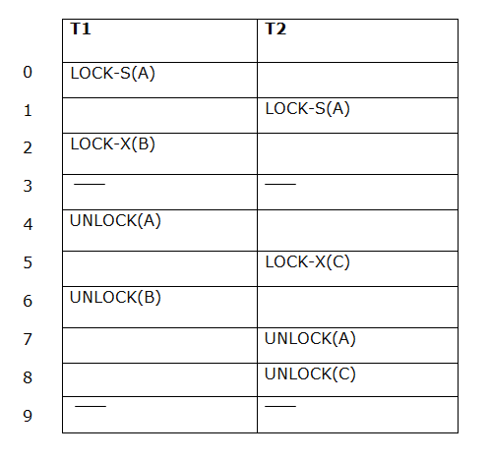
The following way shows how unlocking and locking work with 2-PL.
Transaction T1:
- Growing phase: from step 1-3
- Shrinking phase: from step 5-7
- Lock point: at 3
Transaction T2:
- Growing phase: from step 2-6
- Shrinking phase: from step 8-9
- Lock point: at 6

4. Strict Two-phase locking (Strict-2PL)
- The first phase of Strict-2PL is similar to 2PL. In the first phase, after acquiring all the locks, the transaction continues to execute normally.
- The only difference between 2PL and strict 2PL is that Strict-2PL does not release a lock after using it.
- Strict-2PL waits until the whole transaction to commit, and then it releases all the locks at a time.
- Strict-2PL protocol does not have shrinking phase of lock release.
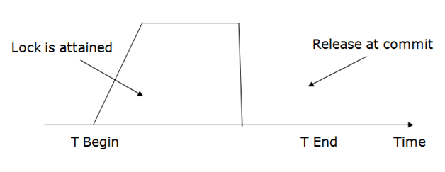It does not have cascading abort as 2PL does.

Timestamp Ordering Protocol
- The Timestamp Ordering Protocol is used to order the transactions based on their Timestamps. The order of transaction is nothing but the ascending order of the transaction creation.
- The priority of the older transaction is higher that's why it executes first. To determine the timestamp of the transaction, this protocol uses system time or logical counter.
- The lock-based protocol is used to manage the order between conflicting pairs among transactions at the execution time. But Timestamp based protocols start working as soon as a transaction is created.
- Let's assume there are two transactions T1 and T2. Suppose the transaction T1 has entered the system at 007 times and transaction T2 has entered the system at 009 times. T1 has the higher priority, so it executes first as it is entered the system first.
- The timestamp ordering protocol also maintains the timestamp of last 'read' and 'write' operation on a data.
Basic Timestamp ordering protocol works as follows:
1. Check the following condition whenever a transaction Ti issues a Read (X) operation:
- If W_TS(X) >TS(Ti) then the operation is rejected.
- If W_TS(X) <= TS(Ti) then the operation is executed.
- Timestamps of all the data items are updated.
2. Check the following condition whenever a transaction Ti issues a Write(X) operation:
- If TS(Ti) < R_TS(X) then the operation is rejected.
- If TS(Ti) < W_TS(X) then the operation is rejected and Ti is rolled back otherwise the operation is executed.
Where,
TS(TI) denotes the timestamp of the transaction Ti.
R_TS(X) denotes the Read time-stamp of data-item X.
W_TS(X) denotes the Write time-stamp of data-item X.

Advantages and Disadvantages of TO protocol:
- TO protocol ensures serializability since the precedence graph is as follows:
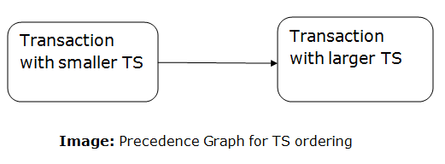
- TS protocol ensures freedom from deadlock that means no transaction ever waits.
- But the schedule may not be recoverable and may not even be cascade- free.

Validation Based Protocol
Validation phase is also known as optimistic concurrency control technique. In the validation based protocol, the transaction is executed in the following three phases:
- Read phase: In this phase, the transaction T is read and executed. It is used to read the value of various data items and stores them in temporary local variables. It can perform all the write operations on temporary variables without an update to the actual database.
- Validation phase: In this phase, the temporary variable value will be validated against the actual data to see if it violates the serializability.
- Write phase: If the validation of the transaction is validated, then the temporary results are written to the database or system otherwise the transaction is rolled back.
Here each phase has the following different timestamps:
Start(Ti): It contains the time when Ti started its execution.
Validation (T_{i}): It contains the time when Ti finishes its read phase and starts its validation phase.
Finish(Ti): It contains the time when Ti finishes its write phase.
- This protocol is used to determine the time stamp for the transaction for serialization using the time stamp of the validation phase, as it is the actual phase which determines if the transaction will commit or rollback.
- Hence TS(T) = validation(T).
- The serializability is determined during the validation process. It can't be decided in advance.
- While executing the transaction, it ensures a greater degree of concurrency and also less number of conflicts.
- Thus it contains transactions which have less number of rollbacks.

Recovery with Concurrent Transaction
- Whenever more than one transaction is being executed, then the interleaved of logs occur. During recovery, it would become difficult for the recovery system to backtrack all logs and then start recovering.
- To ease this situation, 'checkpoint' concept is used by most DBMS.
As we have discussed checkpoint in Transaction Processing Concept of this tutorial, so you can go through the concepts again to make things more clear.

Graph Based Concurrency Control Protocol in DBMS
Graph Based Protocols are yet another way of implementing Lock Based Protocols.
As we know the prime problems with Lock Based Protocol has been avoiding Deadlocks and ensuring a Strict Schedule. We’ve seen that Strict Schedules are possible with following Strict or Rigorous 2-PL. We’ve even seen that Deadlocks can be avoided if we follow Conservative 2-PL but the problem with this protocol is it cannot be used practically. Graph Based Protocols are used as an alternative to 2-PL. Tree Based Protocols is a simple implementation of Graph Based Protocol.
A prerequisite of this protocol is that we know the order to access a Database Item. For this we implement a Partial Ordering on a set of the Database Items (D) {d₁, d₂, d₃, ….., d_{n}} . The protocol following the implementation of Partial Ordering is stated as-
- If d_{i} –> d_{j} then any transaction accessing both d_{i} and d_{j} must access d_{i} before accessing d_{j}.
- Implies that the set D may now be viewed as a directed acyclic graph (DAG), called a database graph.
Tree Based Protocol –
- Partial Order on Database items determines a tree like structure.
- Only Exclusive Locks are allowed.
- The first lock by T_{i} may be on any data item. Subsequently, a data Q can be locked by T_{i} only if the parent of Q is currently locked by T_{i}.
- Data items can be unlocked at any time.
Following the Tree based Protocol ensures Conflict Serializability and Deadlock Free schedule. We need not wait for unlocking a Data item as we did in 2-PL protocol, thus increasing the concurrency.
Now, let us see an Example, following is a Database Graph which will be used as a reference for locking the items subsequently.
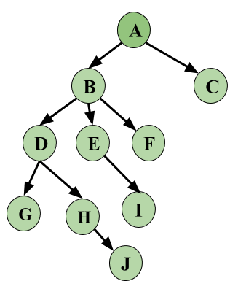
Image – Database Graph
Let’s look at an example based on the above Database Graph. We have three Transactions in this schedule and this is a skeleton example, i.e, we will only see how Locking and Unlocking works, let’s keep this simple and not make this complex by adding operations on data.
 | T₁ | T₂ | T₃
1 | Lock-X(A)
2 | Lock-X(B)
3 |  | Lock-X(D)
4 |  | Lock-X(H)
5 |  | Unlock-X(D)
6 | Lock-X(E)
7 | Lock-X(D)
8 | Unlock-X(B)
9 | Unlock-X(E)
10 |  |  | Lock-X(B)
11 |  |  | Lock-X(E)
12 |  | Unlock-X(H)
13 | Lock-X(B)
14 | Lock-X(G)
15 | Unlock-X(D)
16 |  |  | Unlock-X(E)
17 |  |  | Unlock-X(B)
18 | Unlock-X(G)
From the above example, first see that the schedule is Conflict Serializable. Serializability for Locks can be written as T₂ –> T₁ –> T₃.
Data items Locked and Unlocked are following the same rule as given above and follows the Database Graph.
Thus, let’s revise once more what are the key points of Graph Based Protocols.
Advantage –
- Ensures Conflict Serializable Schedule.
- Ensures Deadlock Free Schedule
- Unlocking can be done anytime
With some advantages comes some Disadvantages also.
Disadvantage –
- Unnecessary locking overheads may happen sometimes, like if we want both D and E, then at least we have to lock B to follow the protocol.
- Cascading Rollbacks is still a problem. We don’t follow a rule of when Unlock operation may occur so this problem persists for this protocol.

Thomas write Rule
Thomas Write Rule provides the guarantee of serializability order for the protocol. It improves the Basic Timestamp Ordering Algorithm.
The basic Thomas write rules are as follows:
- If TS(T) < R_TS(X) then transaction T is aborted and rolled back, and operation is rejected.
- If TS(T) < W_TS(X) then don't execute the W_item(X) operation of the transaction and continue processing.
- If neither condition 1 nor condition 2 occurs, then allowed to execute the WRITE operation by transaction Ti and set W_TS(X) to TS(T).
If we use the Thomas write rule then some serializable schedule can be permitted that does not conflict serializable as illustrate by the schedule in a given figure:
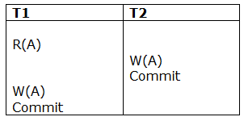
Figure: A Serializable Schedule that is not Conflict Serializable
In the above figure, T1's read and precedes T1's write of the same data item. This schedule does not conflict serializable.
Thomas write rule checks that T2's write is never seen by any transaction. If we delete the write operation in transaction T2, then conflict serializable schedule can be obtained which is shown in below figure.
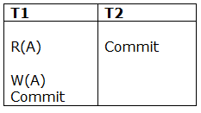
Figure: A Conflict Serializable Schedule

